Low-Level Concerns Policy
- Introduction
At Stoke Goldington Pre School, we take safeguarding very seriously. This includes ensuring that adults who work with children do so in a way that is in accordance with the ethos and policies set out by the Preschool, including the Staff Code of Conduct. This policy sets out the detail and processes for staff regarding low-level concerns they may have.
- Summary
It may be possible that a member of staff acts in a way that does not cause risk to children but is inappropriate. A member of staff who has a concern about another member of staff should inform the Manager about their concern using a Low-Level Record of Concern form. If the Manager cannot be contacted, the Deputy Manager should be informed.
A low-level concern form should also be completed in all cases.
The form will be available directly from:
• The Manager
• Deputy Manager
It can also be requested via email from the above people

- Low level Concerns
A low level concern is not insignificant, but is one that does not meet the threshold for harm and a referral through to the LADO
It includes behaviour such as
- Being overfamiliar with children
- Having favourites
- Shouting at a child
- Acting inconsistently with the school code of conduct
- Engage with a child on a one to one basis in a secluded area or behind a closed door
- Using inappropriate sexualised, intimidating or offensive language
- Inappropriate behaviour out of work such as use of drugs, inebriation or acting in a way that brings disrepute on the school or teaching profession.

These concerns would commonly not have any direct harm to children but may be the result of carelessness or thoughtlessness.

- Investigation of low-level concerns
The Manager or deputy will follow up on all low-level investigations. They should talk to the person reporting the concern (unless this is anonymous) and follow up with the person who the concern is raised about and any witnesses.
The Manager will consider the full details of concerns, if they are unsure if the allegation meets the harm criteria or not then they will consult the LADO for advice and guidance.
If the concern is deemed low level, they will gather information and take any appropriate action, this may involve a disciplinary, retraining or rewriting policies.
The record will be kept on the person’s personnel file. In the event of other allegations being made which meet the Harm criteria for a referral to the LADO, the Manager will share this information fully with the LADO as this will identify any patterns or escalation in behaviour.

- Clarity around Allegation vs Low-Level Concerns vs Appropriate Conduct
Keeping children safe in education 2021 gives clear guidance around these concerns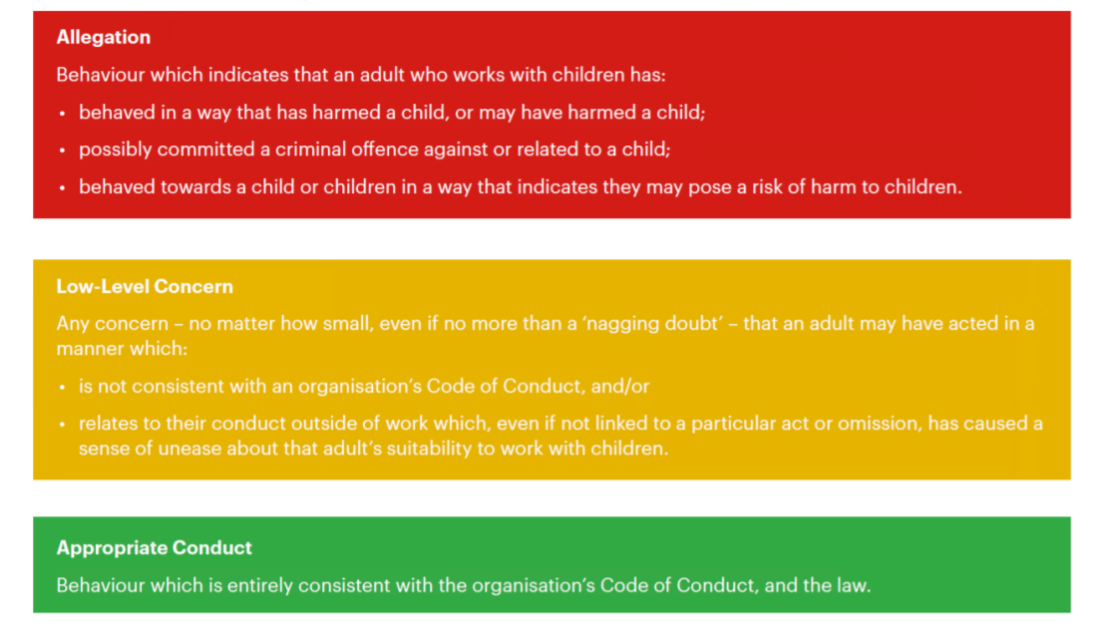
- Storage and use of Low-Level Concerns and follow-up information
Low-Level Concern forms (Appendix 2) and follow up information will be stored securely within the Preschools safeguarding systems on an individual’s personnel file, with access only by the core management team. This will be stored in accordance with the Preschool’s GDPR and data protection policies.
The staff member(s) reporting the concern must keep the information confidential and not share the concern with others apart from the Head Teacher or in their absence the deputy.
Low-Level Concerns will not be referred to in references unless they have been formalised into more significant concerns resulting in disciplinary or misconduct procedures.
Whenever staff leave Stoke Goldington Preschool, any record of low-level concerns which are stored about them will be reviewed as to whether that information needs to be kept.
Consideration will be given to:
- Whether some or all of the information contained within any record may have any reasonably likely value in terms of any potential historic employment ort abuse claim so as to justify keeping it, in line with normal safeguarding records practice; or,
- If, on balance, any record is not considered to have any reasonably likely value, still less actionable concern, and ought to be deleted accordingly.

Appendix 1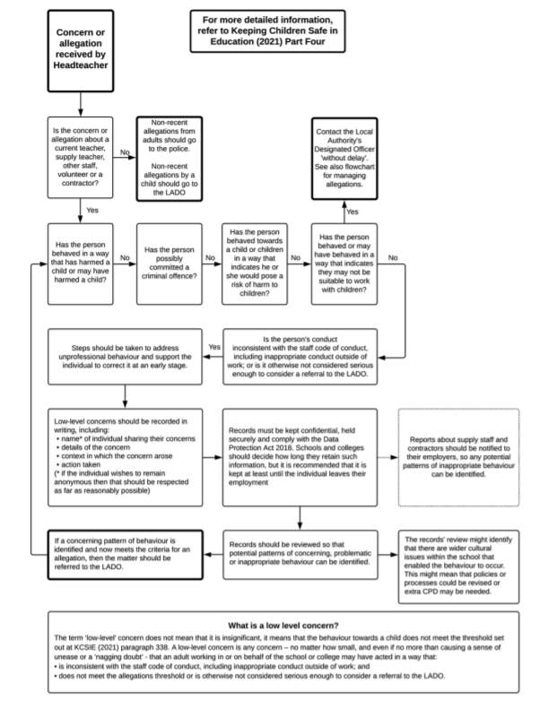

Appendix 2
Low-Level Concern Form
Low-Level Record of Concern Regarding A Staff Member
Please use this form to share any concern – no matter how small, and even if no more than a ‘nagging doubt’ – that an adult may have acted in a manner which:
- Is not consistent with our Code of conduct, and/or;
- Relates to their conduct outside of work which, even if not linked to a particular act or omission, has caused a sense of unease about an adult’s suitability to work with children.
Where possible please speak with the Manager as soon as possible. It is also helpful to document your concerns, which can be done using this form and them passed to the Manager. If the concern is about the Manager, please pass on to the Chairperson.
Remember a low-level concern is different to an allegation.
Date of low-level concern:
Member of staff involved:

Concern information:

Reported by:
Discussion with LADO:
Date and details of discussion

Outcome:

